Pre Calc Name: ______________

______________ ______________

WS Assessment

Target 17

Additional topics

in Trigonometry

* The Law of Sines
* The Law of Cosines
* Vectors: Operations and Applications
* Components of Vectors and Unit Vectors
* Complex Numbers in Trigonometric Form
* Using DeMoivre's Theorem to find Powers and Roots of Complex Numbers

HW 17 Additional Topics in Trig deltamath.com

Solving Triangle: Law of Sine and Law of Cosine

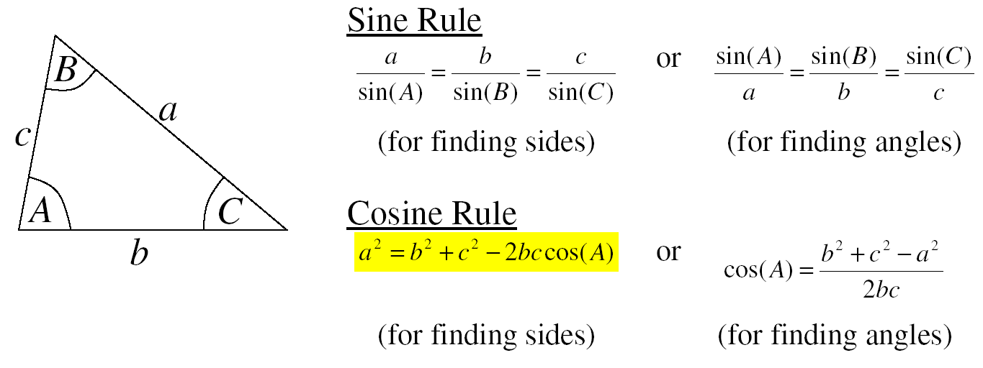

There are 3 sides and 3 angles. Problem will give any three and ask for the remaining three.

|  |  |  |
| --- | --- | --- |
| Given 2 sides and 1 angle in between | Given 2 sides and 1 angle not in between | Given 2 angles and 1 side in between |
| Given 2 angles and 1 side not in between | Given 3 sides |  |

Because of prevailing winds, a tree grew so that it was leaning 4o from the vertical. At a point 35 meters from the tree, the angle of elevation to the top of the tree is 23o.

Find the height of the tree

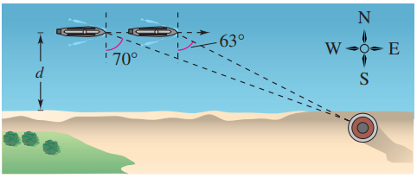A boat is sailing due east parallel to the shoreline at a speed of 10 miles per hour. At a given time, the bearing to the lighthouse is S 70o E, and 15 minutes later the bearing is S 63o E (see figure). The lighthouse is located at the shoreline. What is the distance from the boat to the shoreline?

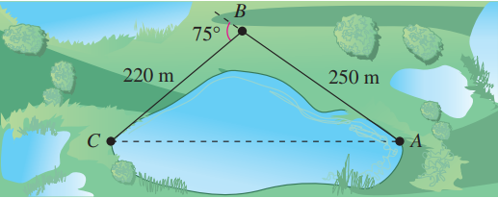To approximate the length of a marsh, a surveyor walks 250 meters from point to point , then turns and walks 220 meters to point (see figure). Approximate the length of the marsh.

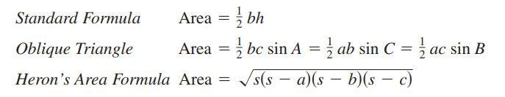

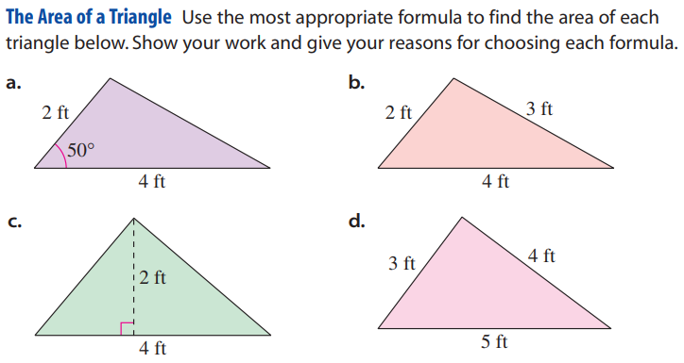Area of Triangle

Quantities such as force and velocity involve both **magnitude** and **direction** and cannot be completely characterized by a single real number. To represent such a quantity, you can use a directed line segment, called vector. The directed line segment $\vec{PQ}$ has initial point P and terminal point Q.

Its magnitude (or length) is denoted by $\left\|\vec{PQ}\right\|$ and can be found using the Distance Formula.

Component form $v=〈a, b〉$ where a = (x2 – x1) and b = (y2 – y1)

Given R = (-4, 2) S = (-1, 6) O – (0, 0) and P = (3, 4). Show that $\vec{RS}$ = $\vec{OP}$ (same length and direction)

Let v is compent of RS, v = (___, _____). Let u is compent of OP, u = (___, _____).

Its length $\left\|v\right\|$ = ? Direction, slope RS = Its length $\left\|u\right\|$ = ? Direction, slope OP =

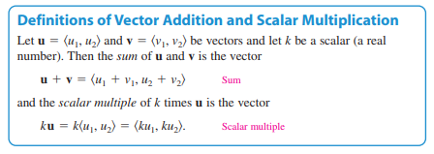Given $u=〈-1,3〉$ and $v=〈4, 7〉$. Find the component and magnitude of

both algebra and graphically (geogebra.org). Stamp

u + v 3u 2u – v

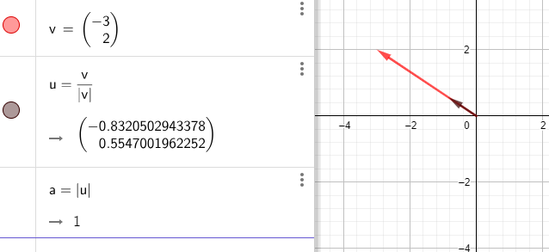

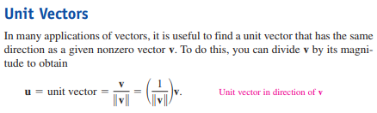

Let $v=〈-3, 2〉$ Find its unit vector and confirm that its magnitude is 1

The unit vector i $=〈1, 0〉$ (x-axis) and $j=〈0, 1〉$ (y-axis) are the standard unit vector. Any vector v can be rewritten using standard unit vectors as $v=〈a,b〉=ai+bj$

The unit vector in direction of v is $\frac{v}{\left\|v\right\|}=\cos{θ i+ }\sin{θ j }$ where $θ$ is direction angle

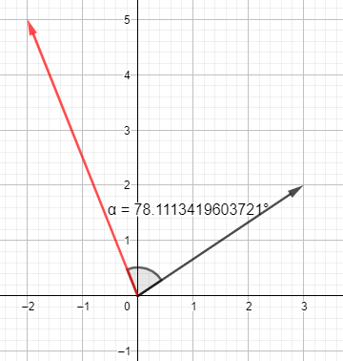

Given $u=〈3, 2〉$ and $v=〈-2, 5〉$.

Find direction angle of u and v, then the angle between u and v.

Stamp graph

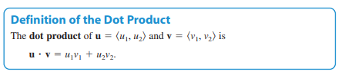Given $u=〈-1,3〉$ and $v=〈4, 7〉$. Find the component and magnitude of (check by geogebra)

u $∙$ v u $∙$ 2v (u $∙v)∙u$

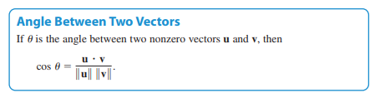Given $u=〈3, 2〉$ and $v=〈-2, 5〉$.

Find angle between u and v (same last problem)

Given $u=〈-2,5〉$ and $v=〈3,2〉$. 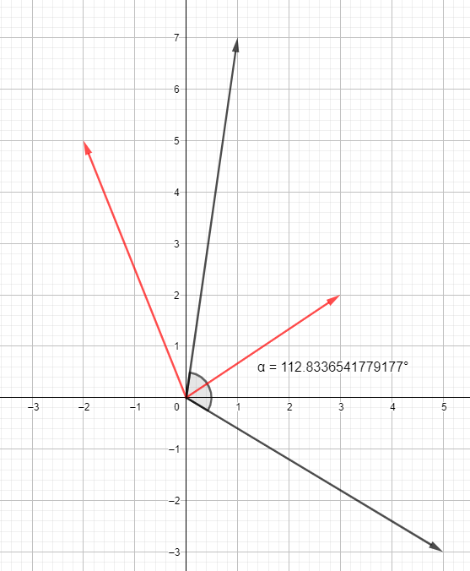Find the component and magnitude of vector m = u + v and n = u – v

Find the angle in between vector m and n in two ways and check by graph. Stamp

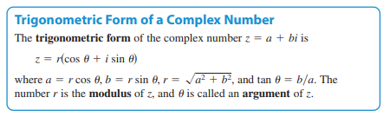

Convert to trig form Convert to standard form

$z=-2-2\sqrt{3}i$ $z=\sqrt{8}\left(cos\left(\frac{-π}{3}\right)+i sin\left(\frac{-π}{3}\right)\right)$

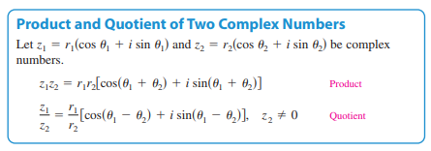

Given two complex number $z_{1}=-1+\sqrt{3}i$ and $z_{2}=\sqrt{48 }$- 4i. Find their product and quotient in both ways (algebra and trig)

Use De Moivre theorem find ${\left(-1+\sqrt{3}i\right)}^{12}$

Find three cube root of z = -2 + 2i

**Target 17 Assessment**

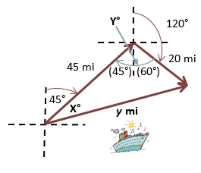A cruise ship travels at a **bearing** of **45°** at **15** mph for **3** hours, and changes course to a bearing of **120°**. It then travels **10** mph for **2** hours. Find the distance the ship is from its **original position** and also its**bearing** from the original position.

Redo this problem using vector

Given vector v = 3i – j and u = -i + 2j. Find the angle between two vectors in two ways

Given two complex number $z_{1}=1+\sqrt{3}i$ and $z_{2}=\sqrt{48 }$ + 4i. Find their product and quotient in both ways (algebra and trig)

Use De Moivre theorem find